CASE 7: Invitrogen (A)
- Acquisitions will always be a part of our strategy due to the pace of the innovation of our business.
— Greg Lucier, Chairman and CEO of Invitrogen
Mark Gardner, Vice President of Corporate Strategy at Invitrogen, walked briskly up the stairs to his office at the company headquarters in Carlsbad, California at 7 a.m. on a bright, sunny day in January 2008. Invitrogen, a leading consumables company in the life sciences space, had just come off an outstanding year, having grown 11 percent to $1.2 billion in revenue. Invitrogen, however, relied primarily on government-funded research, which could limit growth. CEO Greg Lucier and Gardner had worked together for eight years, both at GE and Invitrogen, and Lucier knew he could trust Gardner to “go big-game hunting” and find the acquisition that would dramatically transform Invitrogen into a major platform company in health care.
Gardner wondered what he should recommend to the CEO. He believed that next-generation sequencing was the “strategic elixir” that could transform Invitrogen. There were three companies that could potentially fit this need. Which company would meet the company’s strategic goals?

Invitrogen
Founded in 1987, Invitrogen was one of the largest catalog life science¹ companies in the industry. Its customers came from academic research, biotechnology and pharmaceutical companies and government laboratories. Scientists viewed Invitrogen as a one-stop shop for all major molecular biology, biochemistry and cell culture reagent products, with prices ranging from a hundred dollars to a few thousand dollars.
Invitrogen built its success on an aggressive acquisition strategy combined with merchandising and operational excellence. Since it was founded in 1987, Invitrogen acquired 10 companies under the leadership of Lyle Turner, founder and CEO of Invitrogen. In 2000, Invitrogen made a bold move and acquired Life Technologies, a company four times its size.
In 2003, Lucier was recruited from General Electric to become the CEO of Invitrogen. Upon his arrival, Lucier continued the acquisition strategy. From 2003 to 2005, Invitrogen made an astounding 15 acquisitions (Exhibit 1) so that by 2007, the company had 4,385 employees, 35,000 products,² and tens of thousands of customers. Over time, Invitrogen honed its expertise in integrating companies and streamlining costs.

Exhibit 1: Partial list of Invitrogen Acquisitions from 2003 to 2005
- 1. 2003: $325M acquisition of Molecular Probes, developer of fluorescent based chemistries.
- 2. 2003: $95M acquisition of Panvera, developer of high-throughput drug screening products.
- 3. 2004: Acquisition of Protometrix, privately held developer of protein microarrays.
- 4. 2004: $500M acquisition of Bioreliance, a pharmaceutical services company.
- 5. 2004: $65M acquisition of DNA Research Innovations, privately held company that developed DNA purification technology.
- 6. 2004: $8M acquisition of Bio Asia, leading provider of reagents and services in China.
- 7. 2005: $381M acquisition of Dynal, developer of molecular separation and purification technologies.
- 8. 2005: $130M acquisition of Biosource, developer of kinase and cytokine assays.
- 9. 2005: $60M acquisition of Zymed, developer of antibodies used for research.
- 10. 2005: Acquisition of Quantum Dot, developer of labeling and detection technologies.
- 11. 2005: $20M acquisition of Caltag, developer of immunological reagents.
- 12. 2006: $26M acquisition of Sentigen Biosciences.
- 13. 2008: $57M acquisition of Cellzdirect, developer of hepatocyte-based cell products.
However, not all acquisitions were successful. Bioreliance, a pharmaceutical services business, was acquired for $500 million in 2004, only to be divested for $210 million in 2007. The decision was part of an effort to refocus the company on a “platform of technologies”, rather than services.
Rosy Lee (Sloan ’12), Professor Robert A. Burgelman and Lecturer Robert Siegel prepared this case as the basis for class discussion rather than to illustrate either effective or ineffective handling of an administrative situation.
Copyright © 2012 by the Board of Trustees of the Leland Stanford Junior University. All rights reserved. Used with permission from the Stanford University Graduate School of Business.
With nearly a decade of experience acquiring companies, the process of acquiring was embedded into the Invitrogen way of doing business. The process entailed monthly meetings called Growth and Innovation Board Meetings, more commonly referred to as GIBS. At these meetings, there were three levels of discussions/presentations. First, there was a high-level discussion around a market sector, such as animal health, molecular diagnostics, or penetrating China. Discussion could also be around acquisition targets. Occasionally, Lucier would come to the meeting and say “I’d like to acquire Company X” or a business unit leader would come and say, “I need to acquire Company X in order to achieve my growth target” or “because of a key technology that I need.” Finally, the team would decide which sector to focus on for a deeper analysis. A team of analysts would then be assembled. In the following month, a team would return with a group of targets that met the criteria laid out during the first discussion. The next “ask” was for resources to do a deep analysis on 5 to 15 companies. Finally, an investment thesis on which company to acquire would be developed. In addition, the company needed to understand whether the acquisition would be accretive or dilutive. Often, acquisition targets were watched for months or even years. Even entire integration plans were developed: Which sites would remain? Which groups would be eliminated? Or combined? If there were a significant event, such as an acquisition, the plan would be updated with new information.
New product development was fueled both by acquiring technologies and developing technology in-house. Under Lucier’s leadership, R&D funding doubled from $55 million in 2003 to $112 million in 2007. Typically, new product development for a consumable would take several months to one year with a budget of $500,000 to $2 million for development. Emphasis was placed on rapid product development with iterative product launches. With this pace of investment and development, Invitrogen was able to support 1,420 product launches in 2007.³
Invitrogen’s business was highly transactional so the company focused on merchandising excellence. The company launched hundreds of new products every quarter, such as cell culture media used to sustain and feed cells, Taq polymerase used for PCR, and enzyme and buffer kits for extracting DNA from tissue (see Glossary of Terms). In addition, the company processed several thousand orders per day. As a result, the company’s goal was to drive as much business through the web as possible. Invitrogen invested $83 million in IT,⁴ eventually driving 57 percent of North American orders over the web.⁵ The e-commerce site won numerous industry awards including, the Life Science Industry Award for “Most Useful Website” in 2007. Invitrogen also pioneered the Supply Center, which consisted of onsite refrigerated kiosks located within the customer laboratories to give scientists immediate access to the most commonly use molecular biology reagents 24 hours a day, 7 days a week. Bright and colorful, the supply centers became part of nearly every lab. Any graduate student working late at night knew that s/he could get whatever reagent needed at any time with just a signature on a sign-in sheet. Every week, the local sales representative would pick up the sign-in sheet, take stock of the remaining inventory, charge the laboratory for the reagents and order replacement stock.
To supplement the web and over 1,000 supply centers, Invitrogen also relied on a traditional sales force. There were two groups of sales representatives. The account manager was responsible for overall sales of all 35,000 products. Technical sales specialists focused on specific product areas and provided deeper technical expertise for the account managers. Typically, there were two technical sales specialists for every account manager. Within the team, the account manager typically served as the “quarterback” who set the strategy for the account and served as the lead point of contact. All were compensated with base salary and commission.

Invitrogen’s Future
With 90 percent⁶ of its revenue coming from research, it was clear that Invitrogen would always be at the whim of government funding for the National Institutes of Health (NIH) and National Science Foundation (NSF). The board of directors believed that Invitrogen’s core competencies (what are they? RL: leadership position with the basic research market with products, merchandising, sales) could best be leveraged to solve the medical problems of the twenty-first century. This sentiment was particularly acute as the board was made up of former pharmaceutical and clinical executives (Johnson & Johnson, Smithkline Beecham, and St. Jude Medical). With Lucier at the helm, Invitrogen sought to transform itself from a reagent kit company to a healthcare company.
In the CEO letter to the shareholders in the 2004 Annual Report, Lucier wrote:
- Over the next several years, we hope to alter the course of our company to more directly serve physicians and patients. The idea that a tools company should remain solely in the laboratory is dated. Due to the pressures facing our clients, and because the value creation is much greater as we move toward the human, we believe that moving towards the patient is the right path for Invitrogen. Our steps will be modest in the beginning. We will continue to explore technologies to both enhance our expanding definition of what constitutes molecular tools and to open up our thinking about how to better treat people with cancer. I am convinced we must continue to drive the business toward a more complete understanding of the human system. As we progress we hope to create new business opportunities in the prediction, diagnosis, treatment, and monitoring of challenges to human health. We’re excited by the possibilities of making a bigger difference in the human condition.
In addition, Invitrogen believed that acquiring instrument development and commercialization capability was key to achieving growth and transformation. For example, Invitrogen had the largest portfolio of products in the $6 billion cell biology market and was rated as the number one brand. Yet, Invitrogen had only 12 percent market share because most of the research funding was going toward instrumentation purchases.

Next-Generation Sequencing: Path to Personalized Medicine?
The first human genome was sequenced using Sanger sequencing at a cost of $3 billion⁷ and took nearly 10 years to complete. While the project was hailed as a success, scientists believed that the medical and clinical application of the human genome would be limited until full sequencing could be performed routinely for the price of a diagnostic (~$1000).
The arrival of “next-generation sequencing” (NGS) changed all that. NGS referred to a family of new technologies that radically reduced the time and cost of sequencing. What had cost $3 billion was now approaching $100,000. Many believed NGS would lead to personalized medicine, which would enable physicians to prescribe therapeutics that are tailored to each patient based on his or her genetics.
Initially, three players entered the NGS space. Roche, a $45 billion global healthcare company, was the first to market in 2005 with the 454 System, which promised to sequence a human genome for less than $100,000 in just a few weeks.
In January 2007, Illumina launched the 1G Genome Analyzer, whose throughput was ~50 percent higher than that of the 454 System (1 billion bases per run). In the fall of 2007, Applied Biosystems entered with SOLiD, which generated 1-2 billion bases in one run, and then SOLiD 2.0 in April 2008, which generated 5-6 billion bases in one run (see Exhibit 2). The three players were in an intense race with the goal of delivering a $1,000 genome.

Exhibit 2: Market Growth
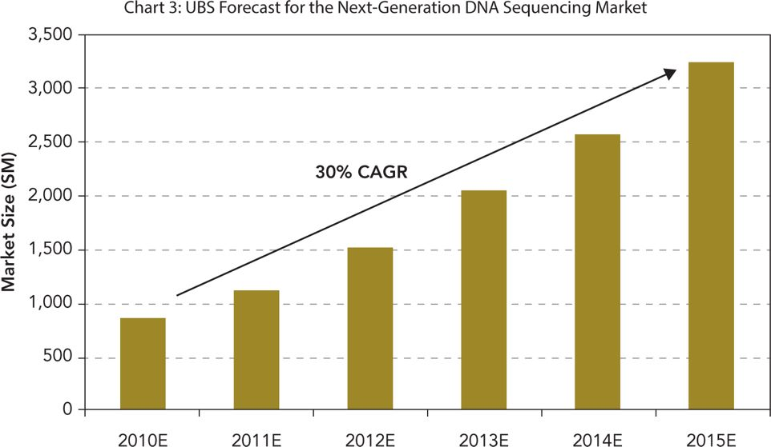
Source: UBS estimates
With sequencing becoming faster and cheaper, laboratories around the world rushed to buy a next-generation sequencer. It was projected that NGS would be a $3 billion market by 2015 (Exhibit 2).
Then in 2008, a fourth player emerged. In 2008, Pacific Biosciences announced that it would commercialize a single molecule sequencer (SMS) that would eventually sequence an entire human genome for $100 in just one hour. Dr. Michael Hunkapiller, former president of Applied Biosystems, was an investor and on the board of directors. There was a tremendous amount of excitement about Pacific Biosciences within the investor community, with rumors that the company had raised nearly $200 million.⁸
Invitrogen, whose reagents were a peripheral component of the NGS workflow, believed that NGS was the transformational opportunity that it was looking for. If every individual in the world was sequenced for $1,000 each, this would translate into a $5.5 trillion market.

Strategic Options
Gardner believed that in order to transform Invitrogen, the company needed two things: instrumentation and a “methodological disruption in the space … as change is the strategic elixir.” Next-generation sequencing was that “strategic elixir.” Initially, acquiring Applied Biosystems seemed to be the best way to achieve Invitrogen’s strategic goal. However, there were many skeptics in the company.

Applied Biosystems
Applied Biosystems was viewed as complementary to Invitrogen and therefore an obvious choice for an acquisition. Both were in the life sciences space, although Applied Biosystems was better known as an instrumentation company.
By 2008, Applied Biosystems was a $2.2 billion instrument and reagent company, with nearly twice Invitrogen’s $1.2 billion of annual revenue. Applied Biosystems’ focus was developing high-quality scientific analytical systems that included high-priced capital equipment ($5,000 to $500,000) and proprietary reagents that were developed exclusively for use on the Applied Biosystems product (akin to the “razor/razorblade model”). Key product lines included PCR, QPCR, and Sanger sequencing. Development of instrument systems could take several years for $20-$50 million. Therefore, each proposed project underwent thorough due diligence on the market, technical, and financial risks before a project was green-lighted.
The sales cycle could last anywhere from a few months to more than a year, depending on the product and the size of the potential order. The goal was to place an instrument, thereby “plugging the socket,” and then rely on the steady stream of reagent revenue and service contract revenue. Applied Biosystems had a highly technical and seasoned field organization. The salespeople used a consultative approach, relying on their technical and scientific expertise and deep relationship with the customer. To support the sales, Applied Biosystems had field application scientists (FAS), who were often PhD scientists who provided technical support and even helped customers design experiments. Applied Biosystems also had a team of field service engineers (FSE) who maintained and repaired the instruments. Often, the three types of employees (sales, FAS and FSE) covered similar territories and worked collaboratively to get leads, support customers, and secure sales. Of the three, only the salespeople were compensated based on commission.
Applied Biosystems typically had one or two major product launches per year. However, each launch typically included a major piece of capital equipment along with proprietary reagents, service components, software, and service contracts. Most of the products were developed in-house,⁹ as Applied Biosystems invested 9-10 percent of revenue in research and development (see Exhibit 3 for Applied Biosystems financials). As a result, Applied Biosystems held 2,400 patents and licenses,¹⁰ approximately twice as many as Invitrogen.

Exhibit 3: NGS Technology Specifications
 | Bases per Read | Price per Run | Time per Run
Sanger Sequencing | 100,000 |  | 24 hours
Roche 454 | 70 Million |  | ~1 week
Illumina 1G Genome Analyzer | 1 Billion | ~$3000 to $5000 | ~1 week
Applied Biosystems SOLiD | 2-3 Billion | ~$8000 | ~2 weeks
Over the previous 10 years, Applied Biosystems made only two major acquisitions: $273 million for Ambion, a Texas-based company that specialized in RNA reagents in 2005, and $120 million for Agencourt Personal Genomics for its “next-generation sequencing” technology.

The Human Genome Project
Applied Biosystems was best known for automated DNA sequencing (called “capillary electrophoresis” or “Sanger sequencing”), which was used to sequence for the government-funded Human Genome Project (HGP). The project was an international effort that began in 1990 to decode all 3 billion chemical units (“bases”) of the human genome. At the same time, Hunkapiller¹¹ believed that a private effort could be accomplished faster than the government effort. He recruited renowned scientist Dr. J. Craig Venter to direct the project, formed Celera Genomics, and the race began. The result was that both government and private efforts completed sequencing in 2003, nearly two years ahead of the original schedule proposed by the U.S. government. The completion resulted in twin publications in Nature and Science, the two most prestigious scientific journals.

Applied Biosystems in Trouble
In 2000, Applied Biosystems and Celera became subsidiaries of a parent company called Applera (derived from a combination of the names Applied and Celera) with Tony White as the CEO. More importantly, Applied Biosystems and Celera traded as two separate tracking stocks. Applera was headquartered in Norwalk, Connecticut, while Applied Biosystems was headquartered in Foster City, California and Celera was headquartered in Alameda, California. There was historically a great deal of concern on Wall Street about the additional overhead to maintain Norwalk, in addition to the corporate airplane that was available only for White’s personal use.¹²
By 2008, Applied Biosystems was at a crossroads. There was a tremendous amount of shareholder unrest. First, revenue growth had stalled. The Human Genome Project had been completed five years earlier, and Wall Street did not see any opportunity for growth. Second, there were significant patents in PCR that were due to expire soon, and with it a significant royalty stream. Sensing volatility in the Applied Biosystems stock, so-called “momentum” or “fast” players had started to take large positions. One such fund was SAC Capital Advisors, whose founder Steve Cohen had a contentious relationship with Tony White, the CEO of Applera. In April 2008, SAC Capital advisors disclosed that it had increased its stake in Applied Biosystems to 5.1 percent (8.6 million shares). In addition, SAC disclosed in a 13D¹³ filed with the SEC that it had sent a letter to Applied Biosystems’s non-management directors to express
- … its continued support for the separation of the Issuer’s Celera Group and encouraging the Board of Directors to take action to ensure that (1) excess costs associated with the Applera parent company and the Norwalk, Connecticut headquarters are eliminated instead of being absorbed by the Issuer’s Applied Biosystems Group, (2) the Issuer’s current Chairman and Chief Executive Officer ceases to be an officer or director of the Applied Biosystems Group, and (3) all strategic alternatives are fully explored, including the sale of the Applied Biosystems Group.

Illumina
Founded in 1998, Illumina was a leading San Diego-based SNP genotyping company. CEO Jay Flatley joined in 1999 and grew the company from $1.3 million in revenue in 2000 to $184 million in 2006. Flatley was a veteran of the sequencing market, having been a cofounder and CEO of Amersham, whose “MegaBase” sequencer was the main competitor of Applied Biosystem’s sequencers. Like Applied Biosystems, Illumina sold capital equipment. Its flagship product “BeadStation” listed for several hundred thousand dollars and generated $600,000 in reagent revenue per instrument annually. Illumina had the sales and service infrastructure required to support a global install base of 300 instruments.¹⁴
In 2006, Illumina jumped into the next-generation sequencing race with the $600 million acquisition of Solexa (based in Hayward, California) and prepared for the launch of its 1G Genome Analyzer. With the acquisition of Solexa, Illumina was poised to enter the next-generation sequencing market with a new technology that could prove to be cheaper and faster than the competition. As John West, CEO of Solexa, stated, “Together we expect to reach and exceed the milestone of the $100,000 genome.”¹⁵ However, it was not clear which technology would be the winning one.

Pacific Biosciences
Pacific Biosciences burst onto the scene in 2006, after being in stealth mode since its founding in 2004. The company officially debuted in February 2008 at the annual AGBT (Advances in Genome Biology and Technology) conference and revealed, for the first time, technical details and plans to commercialize a product in 2010. Using a novel technology called “single-molecular sequencing” or “third-generation” sequencing, Pacific Biosciences promised to deliver a $1,000 genome in 15 minutes. Illumina’s Solexa technology and Applied Biosystems’ SOLiD technology (commonly referred to as second-generation or G2 sequencing) would have required at least 100 or 15 runs, respectively, and cost tens of thousands of dollars. The sequencing community was tremendously excited by the promise of Pacific Biosciences, and some customers were even holding off on purchases of Illumina or Applied Biosystems for a PacBio, whose instrument was listed at ~$700,000. The investor community was equally excited. Led by CEO Hugh Martin, Pacific Biosciences raised nearly $200 million by the fall of 2008.

Evaluating the Options
In order to ensure that all of the stakeholders were heard, Gardner and his team worked with Deloitte Consulting to implement an explicit process for debating the assumptions of the model, for letting everyone have their say, and for getting buy-in on the synergy targets. The team of 20 met weekly for nearly three months. In this way, there were team-driven milestones that everyone would execute even if they were unsure of the deal. Detailed market-based research, technical diligence and customer interviews ensured that nothing was left to chance. During these meetings, many of the stakeholders expressed concern or support.
Applied Biosystems seemed like a good choice because, as a large instrumentation company, it was a good complement to Invitrogen. Lucier realized that the low cost of sequencing would likely shape the next 10 to 30 years of scientific research. To be successful in this environment, a company required strengths in developing and commercializing instruments. In addition, Applied Biosystems had a large forensics business and strategic alliance with Abbott for molecular diagnostics. Both required development expertise for regulated markets, skills that Invitrogen lacked. Lucier and Gardner believed that capitalizing on Invitrogen’s strength in reagent development, the combined companies would be able to achieve product development for cost savings, shorter time-to-market for new products, and secure a larger percentage [of the customer workflow].
From a financial perspective, Applied Biosystems was a sound choice because of its low valuation and large cash reserves. The financial team believed that the acquisition could pay for itself. In addition, activist shareholders had made Tony White vulnerable. Any combined company that emerged was unlikely to have White at the helm. This was a good thing for Lucier, who would want to lead the new company.
However, there were many who did not think Invitrogen should acquire Applied Biosystems.
Members of the R&D community protested that Invitrogen had already invested $20 million¹⁶ in its own third-generation, next-generation sequencing program. The head of R&D believed that the program would be successful and that there was no need to acquire a technology when one could be developed in-house.
The Invitrogen finance team was concerned that the investment community would look unfavorably on this acquisition. Invitrogen had built a reputation on consistent growth and stable cash flow. Acquiring Applied Biosystems would require an enormous amount of debt that would weigh down the stock.
The various business unit heads pointed out that Invitrogen was best at producing and selling low-priced reagents that were transactional. Instrumentation required a very different approach to R&D, sales, and marketing, all of which Invitrogen had never done. What made Invitrogen think they could do this?
Some skeptics in the company wondered why Applied Biosystems was for sale. Did Applied Biosystems know something that the rest did not? After all, key royalties were expiring and Applied Biosystems was losing its leadership in sequencing.
Finally, the company had gone through 10 acquisitions over the last several years and there had been many challenges acquiring companies far smaller than Applied Biosystems. Some believed that this acquisition was simply too big and too difficult. Given the poor track record, they wondered whether they could take on something so big.
Illumina was also an attractive option. The $400,000 1G Genome Analyzer had launched and was relatively well received, having secured 40 orders within 30 days of the completion of the early access period.¹⁷ In addition, Illumina had the commercial infrastructure to support capital equipment, unlike Pacific Biosciences and Invitrogen. However, it was not clear if Illumina’s technology would emerge as the winner. If it did not, then Illumina would be acquiring a microarray company, a technology that many experts claimed would be on the decline with the advent of next-generation sequencing. On the other hand, the Illumina management team included some veterans of the sequencing market and combined with Invitrogen’s consumables development team, they would go to market with a strong, integrated solution.
One looming question was the issue of who would lead the combined companies post-merger. In the case of Illumina, Flatley had a strong record, having grown the company from $99 million in 1999 to $367 million by the end of 2007. In addition, the Solexa acquisition was viewed favorably by the stock market (Exhibit 4).

Exhibit 4: Illumina Stock Price from 2006 to 2008
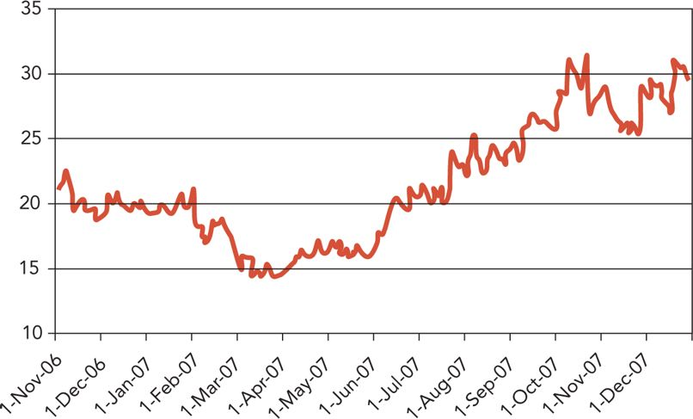
*Includes stock splits.
Key dates: Solexa acquisition announcement in November 2006. Deal closed in January 2007.
Some skeptics worried about Pacific Biosciences. After all, Invitrogen had its own G3 technology program and the team understood all of the technical challenges and wondered how much progress Pacific Biosciences could have made. There had to be plenty of development remaining if a product was not going to be available until 2010. Furthermore, Pacific Biosciences had already raised nearly $200 million, so the company was likely to be valued at $1 billion.

Exhibit 5: Biographies (2012)
Greg Lucier, 43, has been the CEO and Chairman of the Board of Invitrogen since 2003. Previously, he was CEO and president of GE Medical Imaging Information System. He earned his BS in engineering from Pennsylvania State University and MBA from Harvard Business School.¹⁸
Mark Gardner, 43, has held various positions at Invitrogen since 2003, including VP of Corporate Strategy, Chief Marketing Officer, and VP of Product Management/GM of the several business units. Prior to Invitrogen, he was with GE and McKinsey. He served for 10 years in the U.S. Navy with the rank of Lieutenant Commander. He earned his BS in history from the U.S. Naval Academy, MA in National Security Studies at Georgetown University and MBA from University of Pennsylvania Wharton School of Business.¹⁹
Tony White, 60, is the Chairman, President and CEO of Applied Biosystems, then Applera Corporation since 1995. Previously, he held many senior management positions during his 26-year tenure at Baxter International. He earned a BS from Western Carolina University.²⁰
Dr. Mike Hunkapiller, 58, spent 21 years at Applied Biosystems helping to build it into a $2B global life science tools company. He also cofounded Celera Genomics. He is the inventor of the automated DNA sequencer, which was used to sequence the human genome. A renowned scientist, he has more than 100 scientific publications and holds more than two dozen patents. He earned a BS in Chemistry from Oklahoma Baptist University and a PhD in Chemical Biology from the Division of Chemistry and Chemical Engineering at Caltech.²¹
Jay Flatley, 55, has been the President and CEO of Illumina since 1999. Previously, he was the cofounder, President and CEO of Molecular Dynamics, which was acquired by Amersham Pharmacia Biotech and is now part of GE Healthcare. He earned a BA in economics from Claremont McKenna College and BS and MS (summa cum laude) in industrial engineering from Stanford University.²²
Hugh Martin, 53, has been the CEO, President and Chairman of the Board of Pacific Biosciences since 2004. Prior to joining Pacific Biosciences, he was the chief executive office coach at Kleiner, Perkins, Caulfield and Byers. Martin earned a BS in electrical engineering from Rutgers University.
Source: Compiled by author.

Exhibit 6: Selected Financials for Applied Biosystems (Applera Corporation)
(Thousands USD) | 2007 | 2006 | 2005 | 2004 | 2003
Net revenues | $2,093,467 | $1,911,226 | $1,787,083 | $1,741,098 | $1,682,943
Income from continuing operations | $170,875 | $275,117 | $236,894 | $172,253 | $199,617
Per Share Information
Income per share from continuing operations Basic | $0.93 | $1.47 | $1.21 | $0.84 | $0.96
Diluted | $0.90 | $1.43 | $1.19 | $0.83 | $0.95
Dividends | $0.17 | $0.17 | $0.17 | $0.17 | $0.17
Cash & Cash equivalents and short-term investments | $494,464 | $373,921 | $756,236 | $504,947 | $601,666
Total Assets | $2,386,604 | $2,245,772 | $2,259,159 | $1,921,672 | $2,105,179
Long-Term Debt | $0 | $0 | $0 | $0 | $0
Source: Applera Annual Report 2007.

Exhibit 7: Selected Invitrogen Financials
(Thousands USD) | 2007 | 2006 | 2005 | 2004
Net revenues | $1,282 | $1,151 | $1,198 | $1,024
R&D | $112 | $100 | $97.0 | $73.1
Net Income | $143 | –$191 | $132 | $88.8
Per Share Information
Income per share from continuing operations Basic | $2.79 | $1.47 | $2.33 | $1.57
Diluted | $2.69 | $1.44 | $2.15 | $1.50
Dividends
Free Cash Flow | $245 | $174 | $238 | $214
Total Assets | $3,330 | $3,183 | $3,877 | $3,614
Long-Term Debt | $1,151 | $1,151 | $1,152 | $1,319
Source: Invitrogen Financial Reports.
On the other hand, many believed that the potential of G3 technology was so great, it would overtake and even obsolete the technologies developed by Applied Biosystems, Illumina and Roche. They wondered if it made more sense to “skip over” next-generation sequencing and acquire Pacific Biosciences to get a head start with G3 technology.

Next Steps
Gardner started to make his way over to Lucier’s office for their weekly 1:1. He knew that Lucier would want to know what Gardner would recommend. Which company should Invitrogen acquire? Gardner and his team had been working diligently on the financial models. An acquisition could bring great rewards, but great risks as well. An acquisition would bring painful layoffs and site closures. “The math part is easy,” thought Gardner, “but the real question is: Is it worth it? And are we ready?”

